# Degenerate distribution

Def

PDF

$$f\left(x;k_{0}\right)$$

= $$1$$, if $$x==k_{0}$$

= $$0$$, otherwise

CDF

$$F\left(x,k_{0}\right)$$

= $$1$$, if $$x≥k_{0}$$

= $$0$$, otherwise

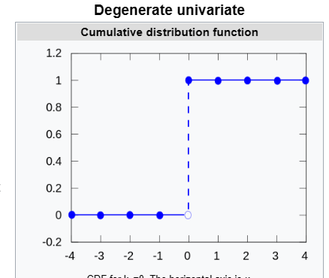

Expected Value

$$k_{0}$$

Variance

$$0$$

Median

$$k_{0}$$

Mode

$$k_{0}$$

Skewness

Undefined

Ex. Kurtosis

Undefined

MGF

$$MGF\left(X,k_{0}\right)$$

= $$e^{k_{0}t}$$

CF

$$CF\left(X,k_{0}\right)$$

= $$e^{ik_{0}t}$$

Ref

[Degenerate distribution - Wikipedia](https://en.wikipedia.org/wiki/Degenerate_distribution)